PROJECT TITLE: CUSTOMER MANAGEMENT SYSTEM
STUDENT NAME: AYEBALE RONAH
REG NO: 2025/BCS/058/PS
COURSE UNIT: DATABASE SYSTEMS
INSTITUTION: MBARARA UNIVERSITY OF SCIENCE AND TECHNOLOGY
PROGRAM: BACHELOR OF SCIENCE COMPUTER SCIENCE
EXECUTIVE SUMMARY
Customer management system is a specialized database solution designed to manage all the customer-related data reducing data loss, poor follow up and inefficient service delivery. The system addresses these problems by storing customer profiles, linking each customer their vehicle service orders, and logging every interaction between the garage and the customer
BUSINESS CASE
Problems
- Lost or misplaced customer records
- No service history tracking
- Poor complaint management
- Inability to generate reports
- No accountability
Solution
The system solves these problems by providing a centralized relational database which stores all customer information in a structured format, links customers to their service jobs ad interactions, and allows garage staff to query the data quickly ad accurately. The database is organized into three core tables that reflect the real world operations of a garage.
Needs of the organization
- Store and retrieve complete customer information
- Track each customer’s account status
- Record all service jobs linked to a customer
- Log all customer interaction with the technicians
- Enable management to filter and query customer datan
Benefits of the system
- Eliminates paper based records and centralizes all customer data in one secure database
- Enables fast lookup of any customer’s full profile, service history and interaction
- Improves customer service y giving staff to interaction history before engaging with a customer
- Supports accountability by timestamping every service order ad interaction automatically
Logical design
Key Database Entities & Attributes
- ServiceOrder
- customer
- Interaction
IMPLEMENTATIONS OF THE ENTITIES

Customer table 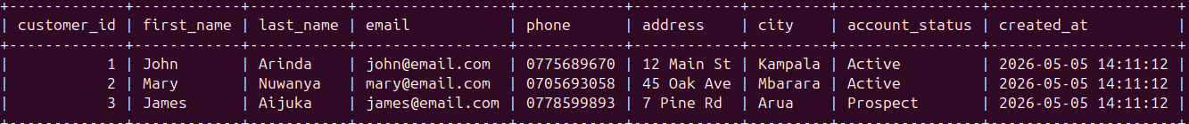
Serviceorder table
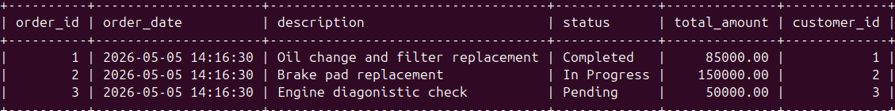
Interaction table
